**Adress Book**

**With**

**Linux Dialog**

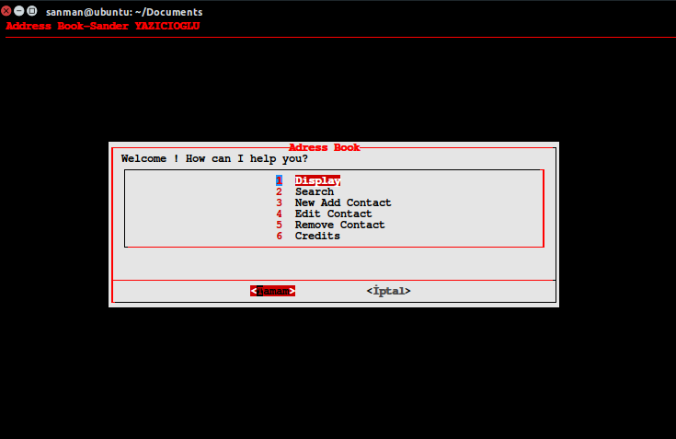

**Sander YAZICIOĞLU**

**160709028**

**Mugla Sitki Kocman University**

**CENG 1006 Social & Professional Issues in CS**

**10/05/2018**

**Adress Book With Linux Dialog**

Sander YAZICIOĞLU

Computer Engineering

Mugla Sitki Kocman University

10/05/2018

**Summary** :

this report has content about how I made cihat çetinkaya's project homework which is my department teacher. I have used the dialog command from linux distribution I have prepared this address book with the help commands in this report.

***TABLE OF CONTENTS***

***1-Introduction---------------------------------------------------------------3***

***2-Methods--------------------------------------------------------------------3***

***3-Results--------------------------------------------------------------------- 3***

***4-Conclusion----------------------------------------------------------------3***

***5-References--------------------------------------------------------------- 3***

***1-Introduction:***

An address book or a name and address book (NAB) is a book or a database used for storing entries called contacts. Each contact entry usually consists of a few standard fields (for example: first name, last name, company name, address, telephone number, e-mail address, fax number, mobile phone number). Most such systems store the details in alphabetical order of people's names, although in paper-based address books entries can easily end up out of order as the owner inserts details of more individuals or as people move. Many address books use small ring binders that allow adding, removing and shuffling of pages to make room. But in this project you will see a script example made with the old BASH coding database.

***2-Methods:***

Address books can also appear as software designed for this purpose, such as the "Address Book" application included with Apple Inc.'s Mac OS X. Simple address books have been incorporated into e-mail software for many years, though more advanced versions have emerged in the 1990s and beyond; and also in mobile phones.

A personal information manager (PIM) integrates an address book, calendar, task list, and sometimes other features.

Entries can be imported and exported from the software in order to transfer them between programs or computers. The common file formats for these operations are:

LDIF (*.ldif, *.ldi)

Tab delimited (*.tab, *.txt)

Comma-separated (*.csv)

vCard (*.vcf)

Individual entries are frequently transferred as vCards (*.vcf), which are roughly comparable to physical business cards. And some software applications like Lotus Notes and Open Contacts can handle a vCard file containing multiple vCard records.

***3-Results:***

As a result, I have made an address book with BASH encoding, this address book has features to add contacts, delete contacts, view contacts and edit contacts. The dialog command I use a lot helps me.

***4-Conclusion:***

I had difficulty in the beginning but when I learned the commands, I made a project that developed spontaneously. When I was preparing, I encountered a lot of problems and inevitable problems due to insufficient resources.

***5-References:***

[***http://linuxcommand.org/lc3_adv_dialog.php***](http://linuxcommand.org/lc3_adv_dialog.php)

[***https://www.linuxjournal.com/article/2807***](https://www.linuxjournal.com/article/2807)

[***https://linux.die.net/man/1/dialog***](https://linux.die.net/man/1/dialog)